PHASE – 4
Infrastructure Design
- Purpose
The Infrastructure Design phase defines the complete architecture of the OpenStack production environment. It specifies how physical servers, network infrastructure, storage components, and OpenStack services will be organized to deliver a scalable, secure, and highly available private cloud platform The design serves as the blueprint for implementation and ensures consistency throughout deployment, testing, and production operations.

Design Objectives

The infrastructure has been designed with the following objectives:
  - Build a highly available OpenStack environment.
  - Eliminate single points of failure.
  - Provide scalable compute and storage resources.
  - Separate traffic using dedicated networks.
  - Support enterprise storage integration.
  - Simplify deployment through Kolla-Ansible.
  - Enable future cluster expansion with minimal changes.
  - Maintain secure communication between services.

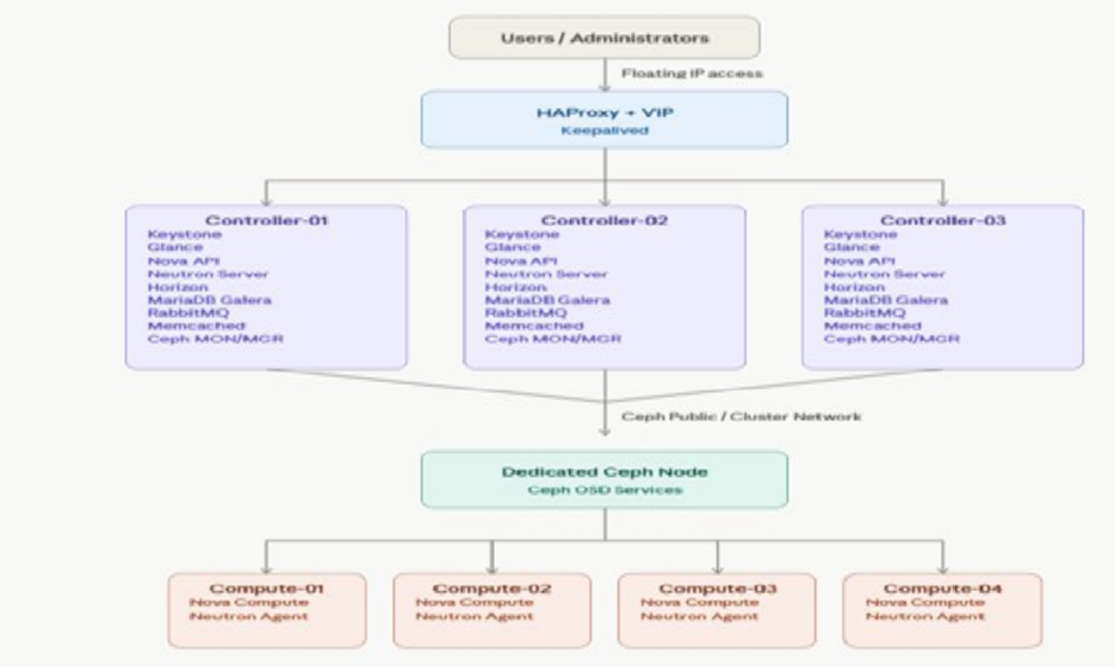
High-Level Infrastructure Architecture

- Physical Infrastructure Design

Physical Node Layout

Server Name Role Main Services
Controller-01 Controller + Ceph API Services, Database, RabbitMQ, Ceph
MON
Controller-02 Controller + Ceph API Services, Database, RabbitMQ, Ceph
MON

Controller-03 | Controller + Ceph | API Services, Database, RabbitMQ, Ceph MON
Ceph-01 | Storage | Ceph OSD
Compute-01 | Compute | Nova Compute
Compute-02 | Compute | Nova Compute
Compute-03 | Compute | Nova Compute
Compute-04 | Compute | Nova Compute

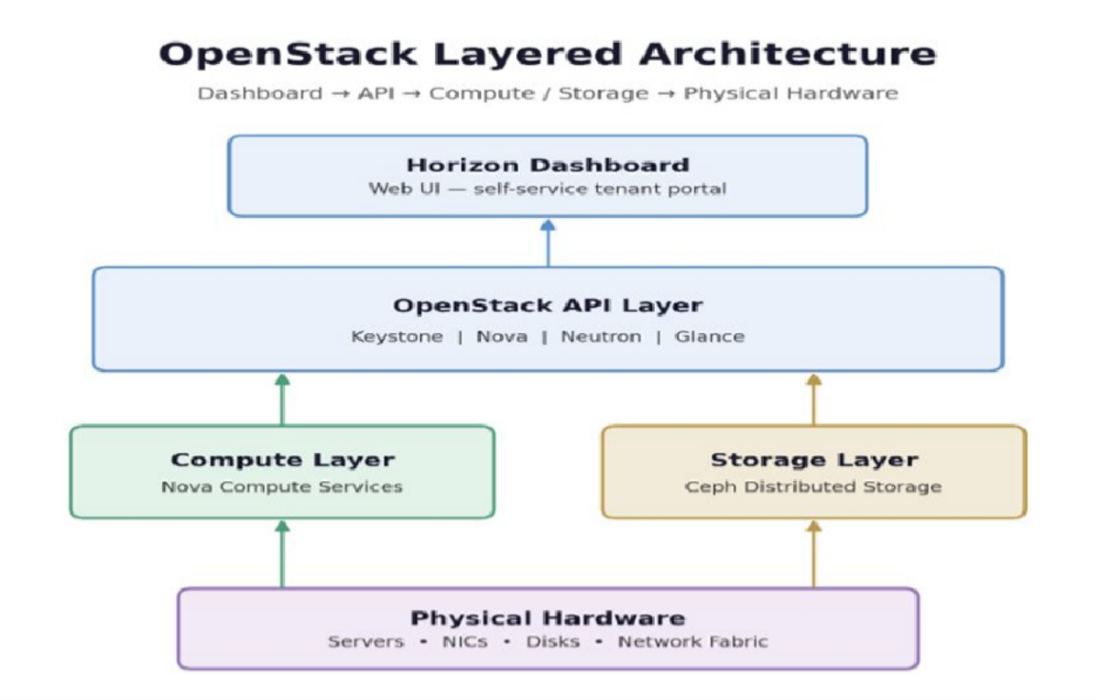
Logical Architecture

- Service Placement Matrix

Service Controller Compute Ceph Node

Keystone  Glance | ✓  ✓
Nova API | ✓
Nova Compute | ✓
Neutron Server | ✓
Neutron Agent | ✓
Horizon | ✓
Placement | ✓
Cinder API | ✓
Cinder Volume | ✓
RabbitMQ | ✓
MariaDB Galera | ✓
Memcached | ✓

HAProxy ✓
Keepalived ✓
Ceph MON ✓
Ceph OSD ✓

Network Design

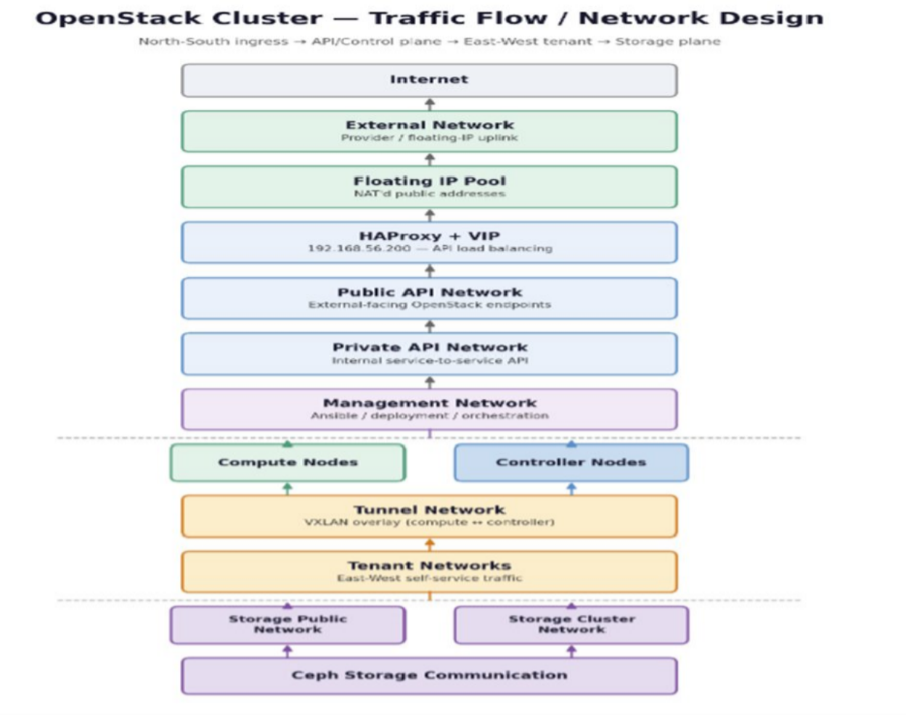
Network Architecture

Network Design Table

Network | CIDR (Example) | Purpose
Management | 192.168.10.0/24 | Node Management
Public API | 192.168.20.0/24 | API Access
Private API | 192.168.30.0/24 | Internal Services
Tunnel | 192.168.40.0/24 | VXLAN Traffic

Storage Public | 192.168.50.0/24 | Ceph Client Access
Storage Cluster | 192.168.60.0/24 | Ceph Replication
External | Organization Network | Floating IP
iSCSI | 192.168.70.0/24 | SAN Storage
NAS | 192.168.80.0/24 | NAS Storage

Storage Architecture

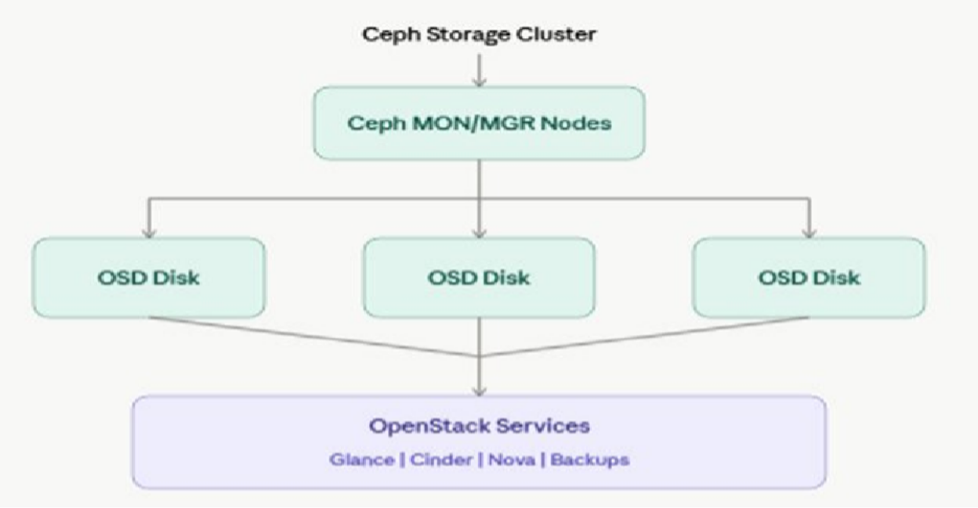
- High Availability Design

 | Component | HA Method
API Access |  | HAProxy + Keepalived
Database |  | MariaDB Galera Cluster
Messaging |  | RabbitMQ Cluster
Storage |  | Ceph Replication
Controllers |  | Multi-Controller Deployment

High Availability Flow
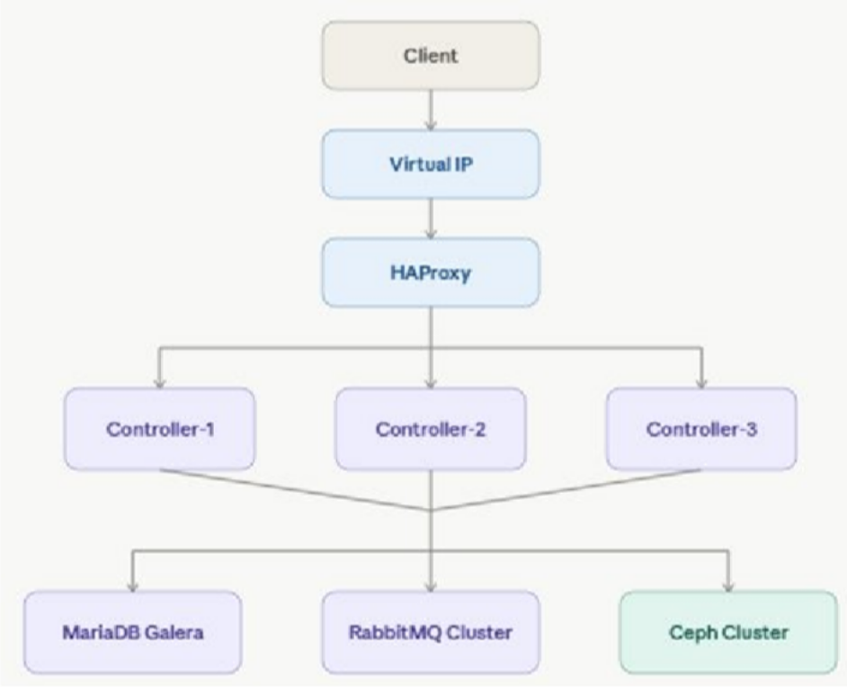

Security Design

Security Component Design Decision
Authentication Keystone Identity Service
Authorization RBAC
API Encryption TLS/SSL
SSH Access Key-based Authentication
Firewall Network-Level Filtering
Tenant Isolation Neutron Security Groups
Image Protection Glance Image Validation

Scalability Design

The infrastructure has been designed to support future expansion without major architectural changes.

 | Component | Expansion Capability
Controller Nodes |  | Add additional controllers if required
Compute Nodes |  | Add new compute nodes to increase VM capacity

Ceph Storage Add OSD disks or new storage nodes
Networks Add new VLANs for future workloads
OpenStack Services Enable additional services such as Heat, Magnum, Octavia, or Designate

